Table of Contents

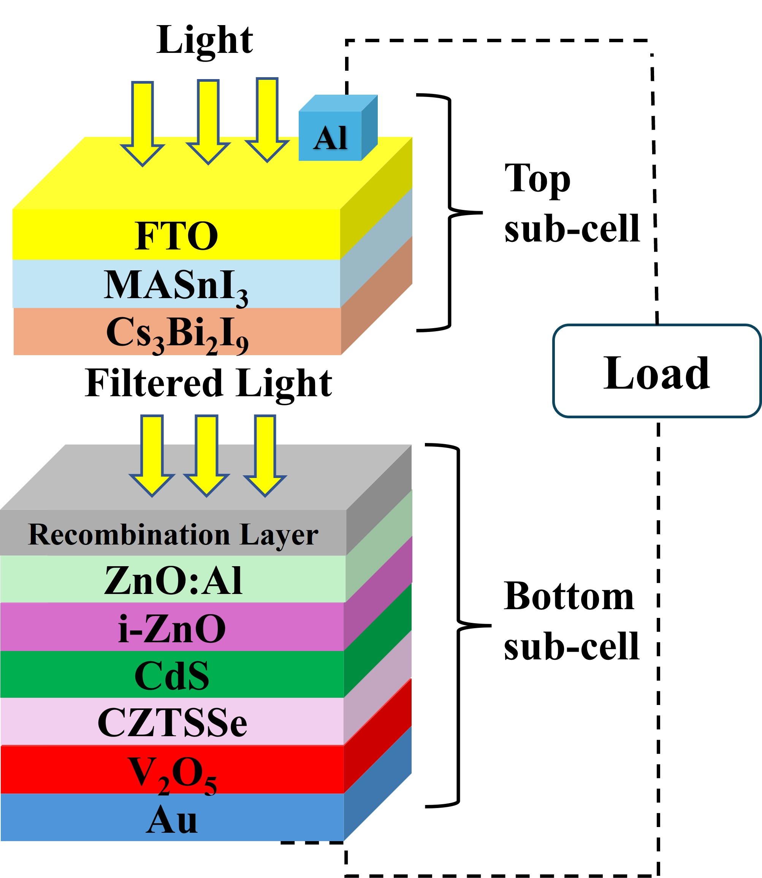
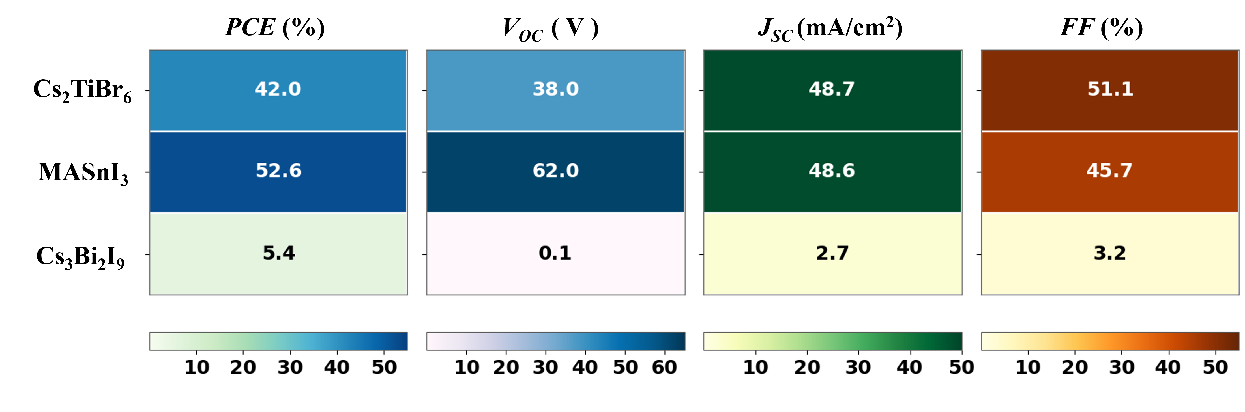
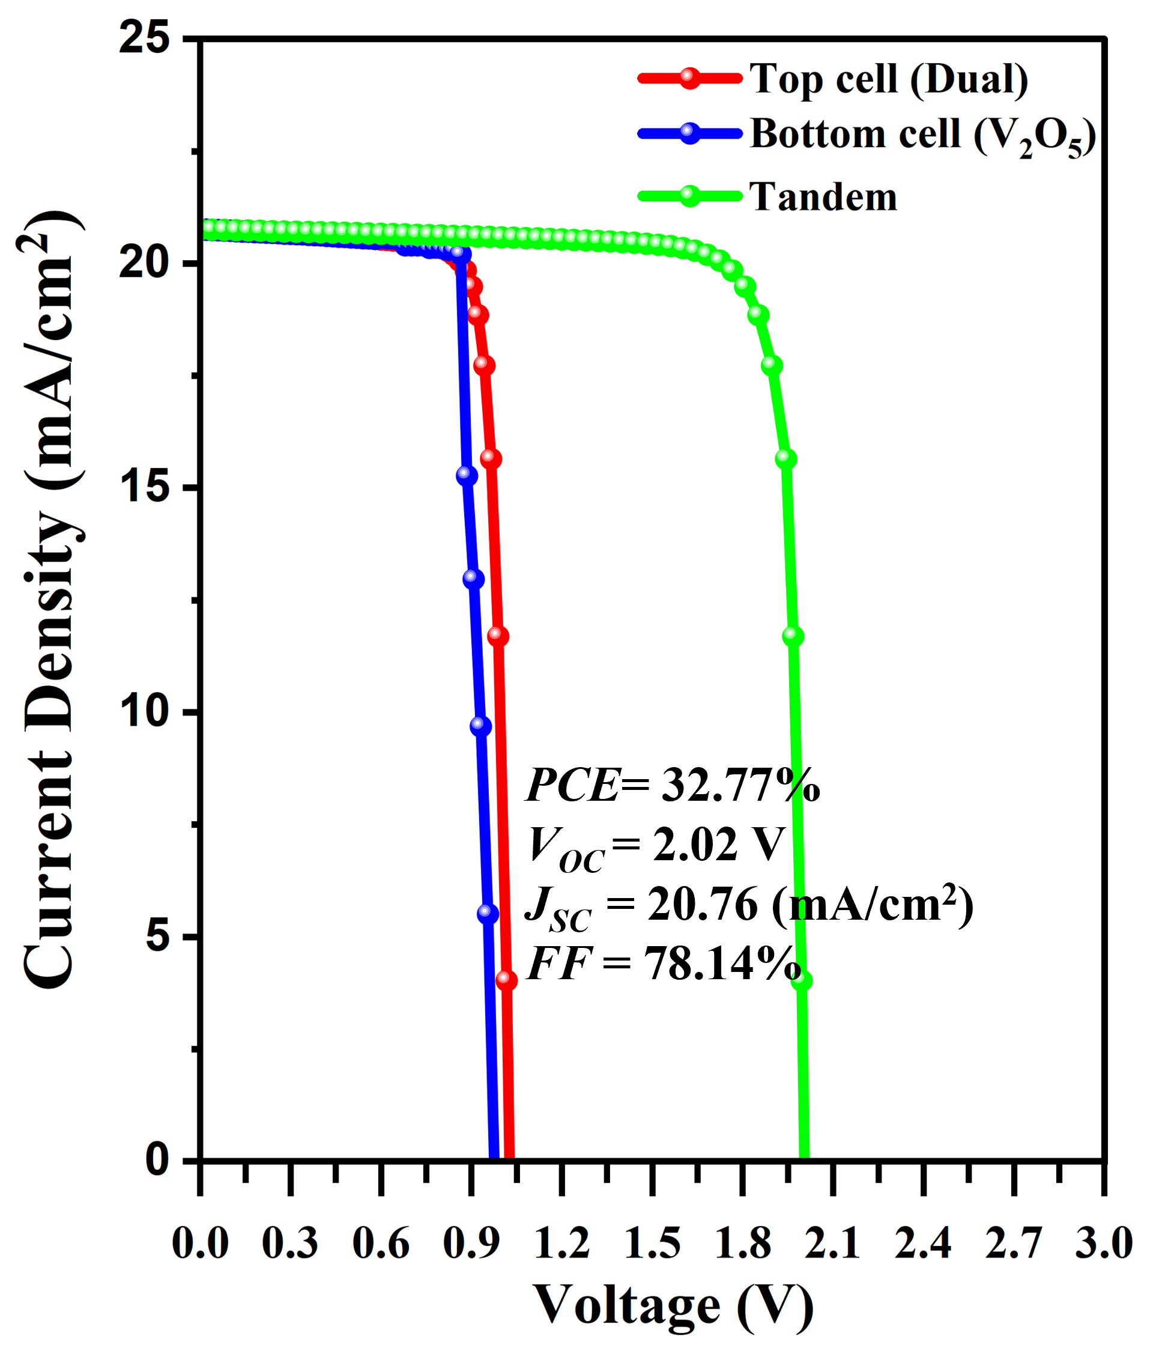
Best of six lead-free perovskite/CZTSSe 2T tandems reaches 32.77% PCE; machine learning identifies MASnI₃ as the key absorber.

